**Module 4 – Task 1**

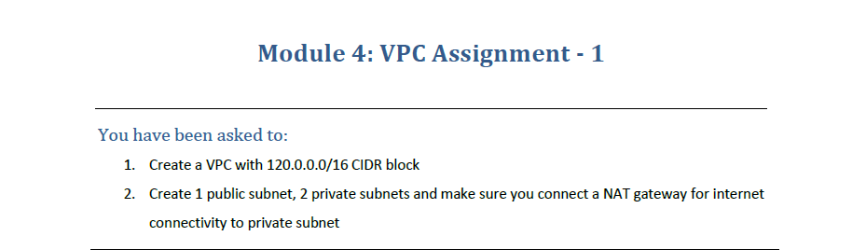

**VPC Assignment**

1. Search for VPC and Click on Create VPC.

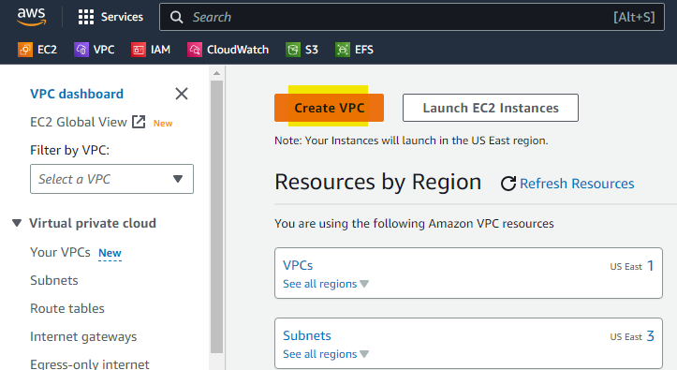

1. Select VPC Only and assign IPV4 CIDR as 120.0.0.0/16

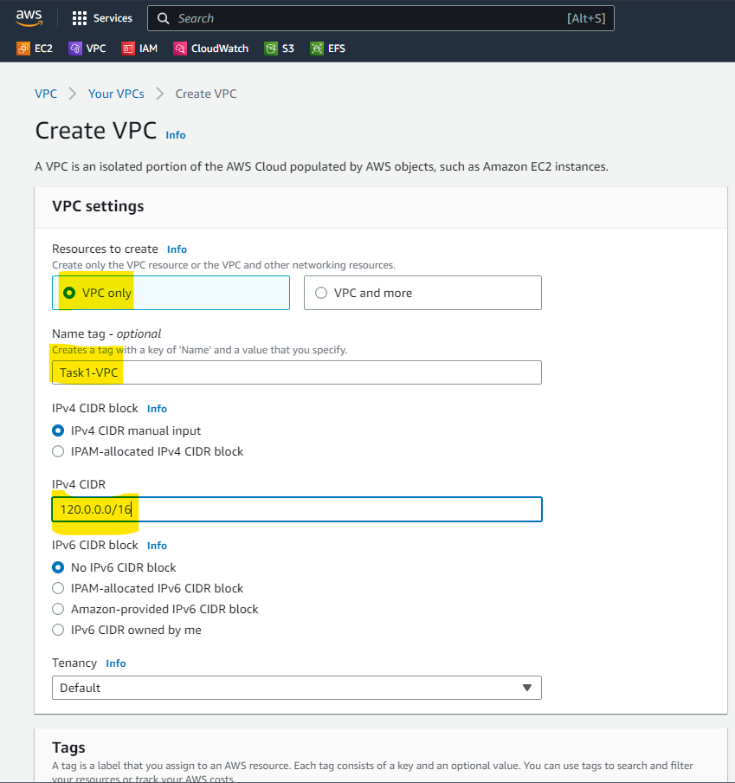

1. After Creating the VPC, Create 3 Subnet in the New VPC (1 Public and 2 Private)

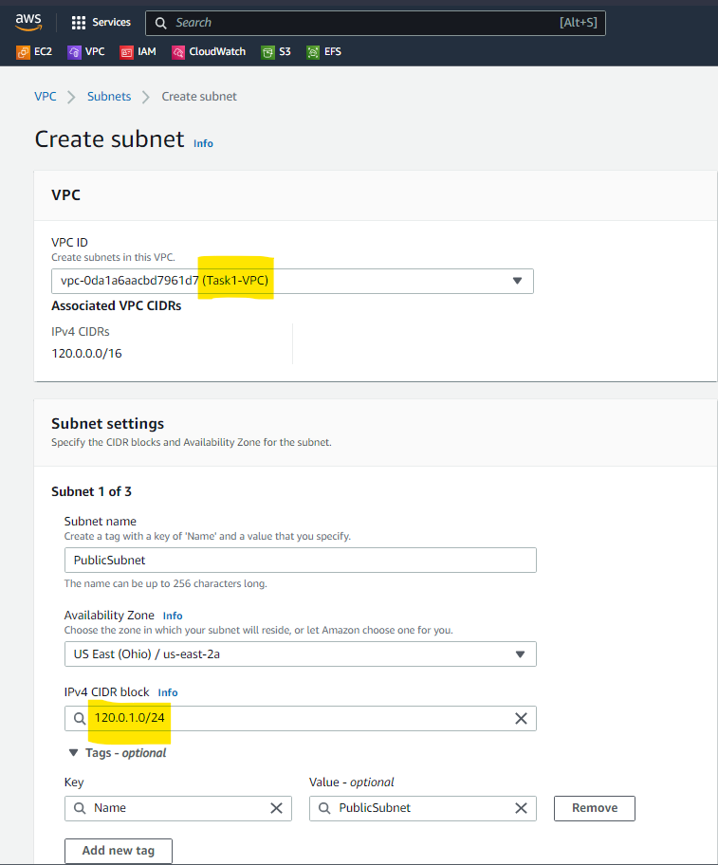

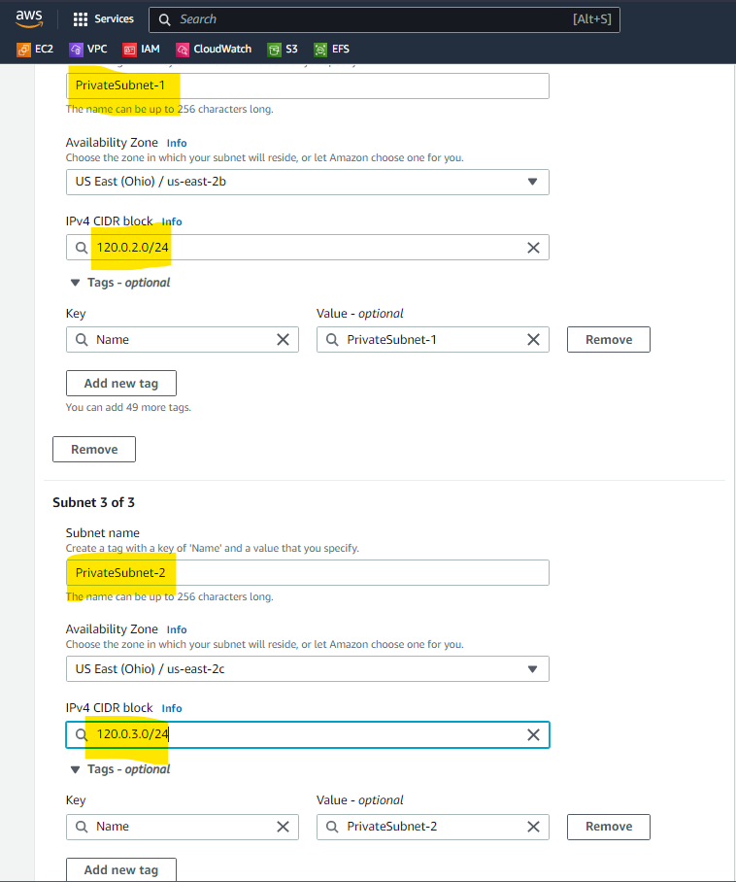

1. Create 2 Route Table, one for Private Subnet and another for Pubic Subnet.

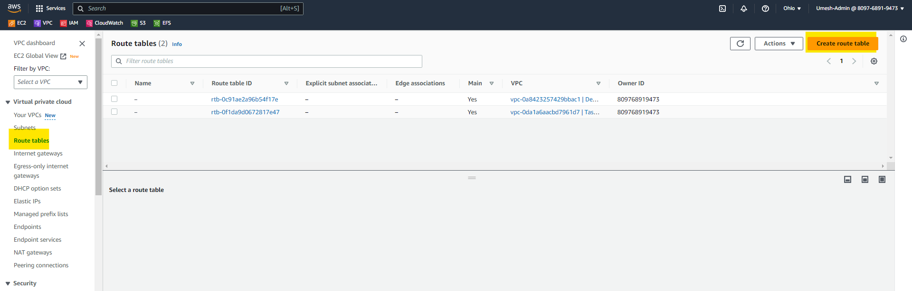

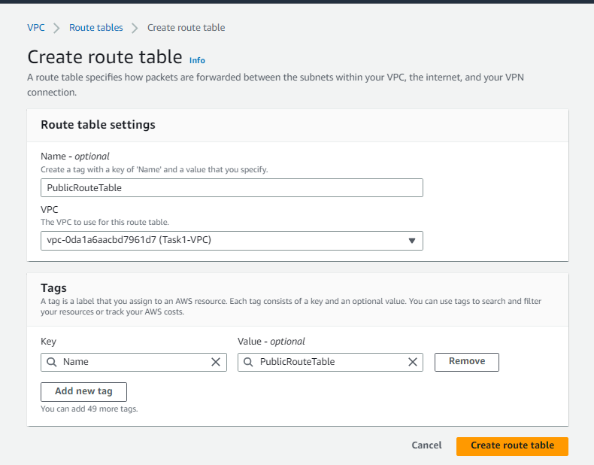

1. Create an Internet Gateway and Attach it to Public Route Table to Establish Internet Connectivity in the Public Subnet.

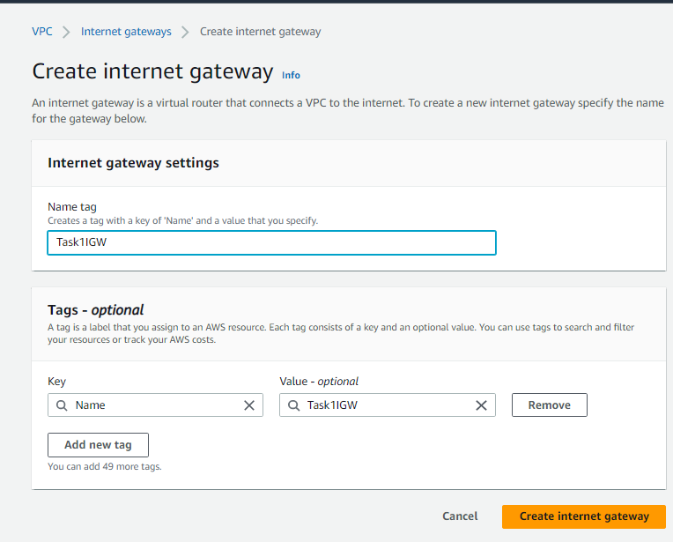

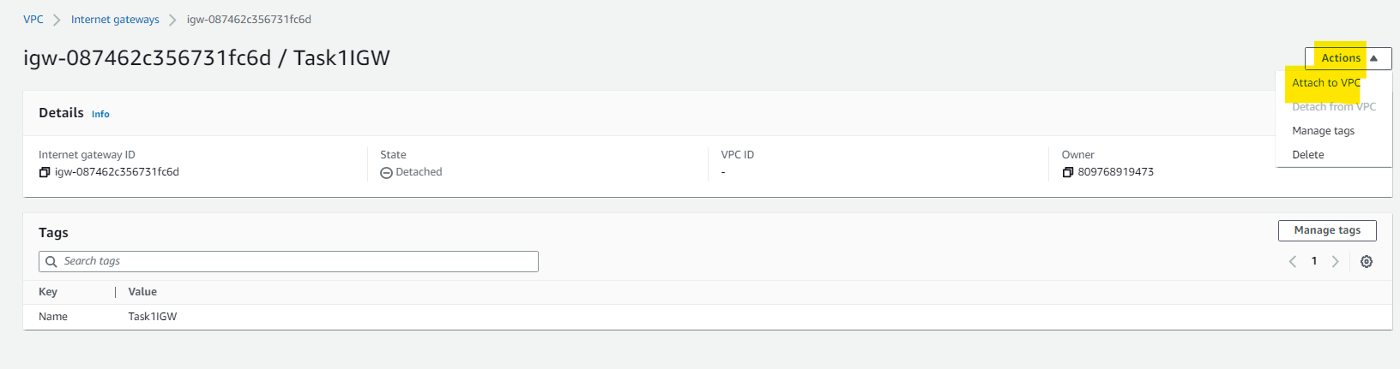

1. Edit the Public Route Table and Add IGW.

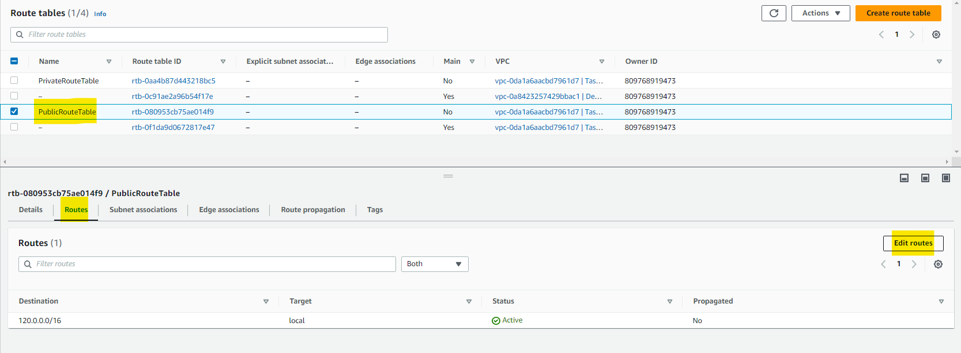

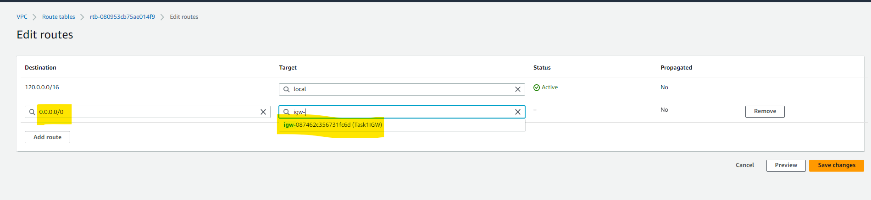

1. Associate Public Subnet into Public Route Table and Private Subnet to Private Route Table.

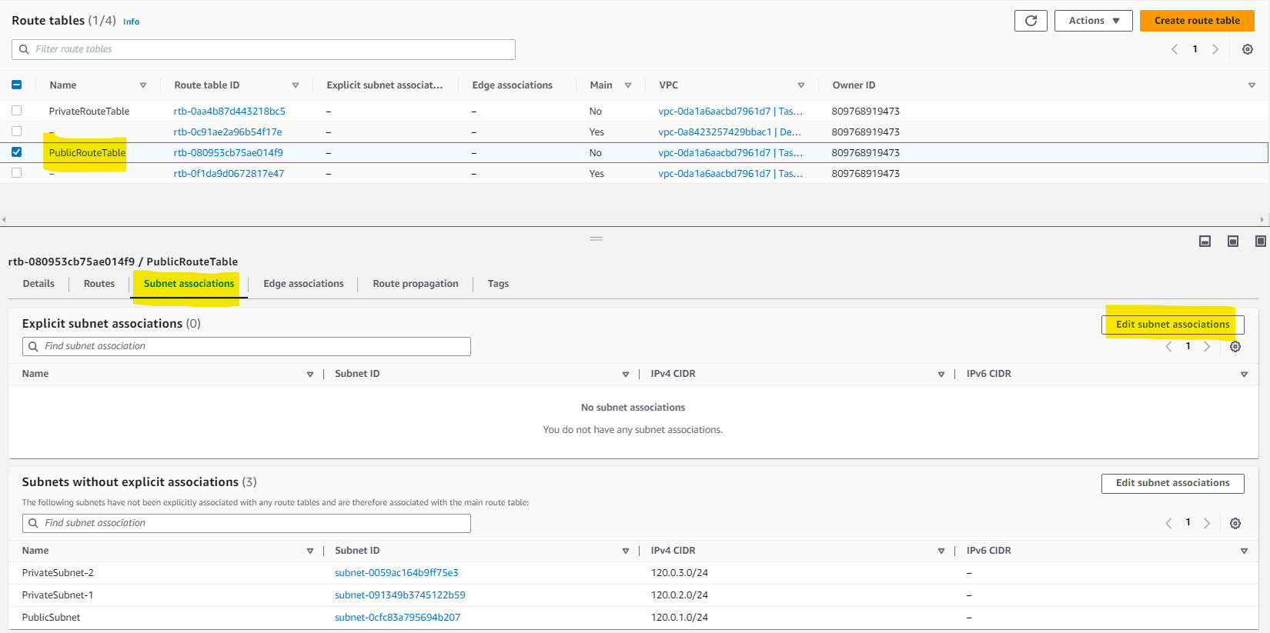

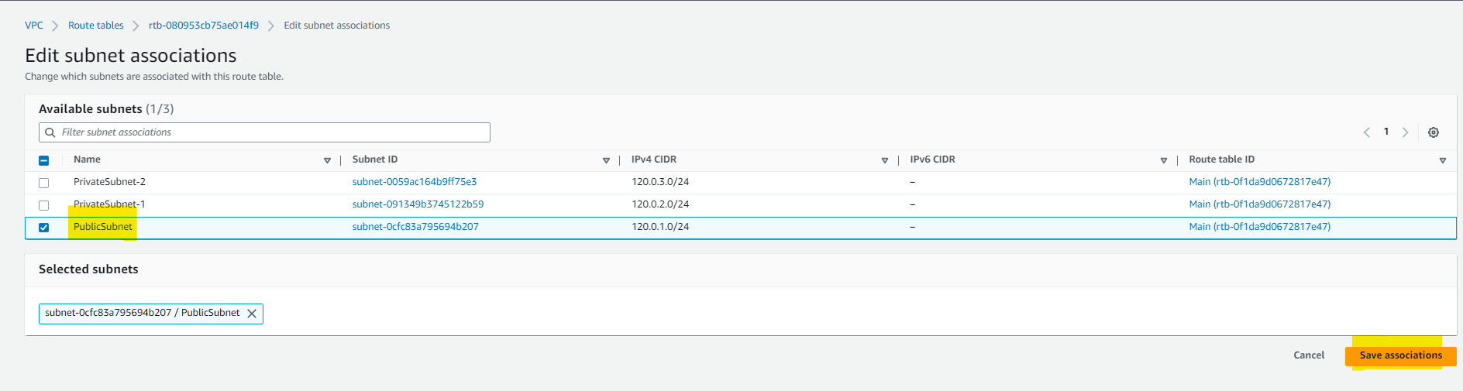

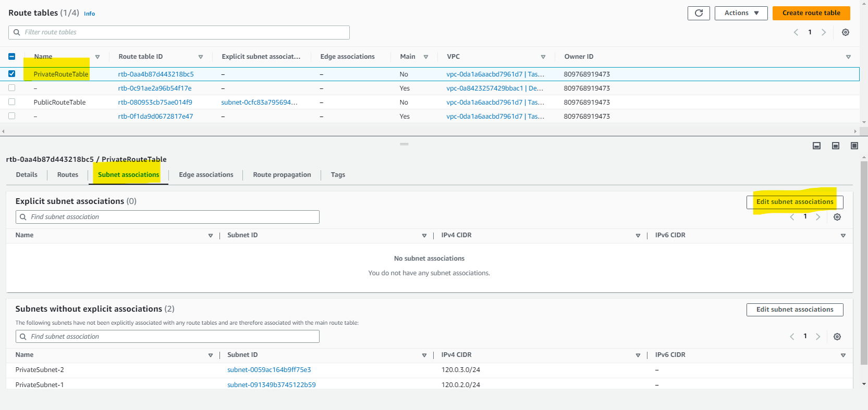

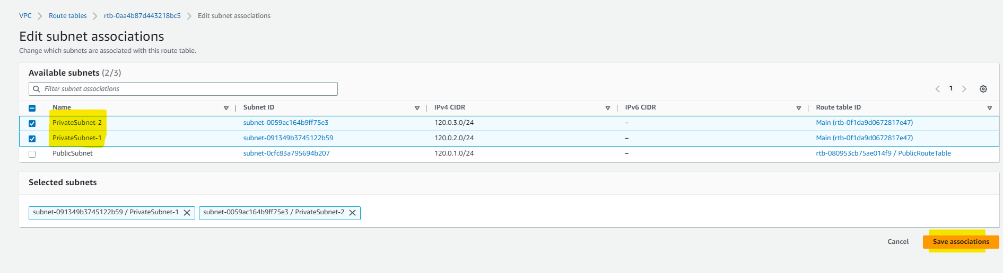

1. Create a NAT Gateway in Public Subnet and Edit the Private Route Table and add a Route for NAT Gateway so that Private Subnet can access the Internet through NAT as Public accesses through IGW.

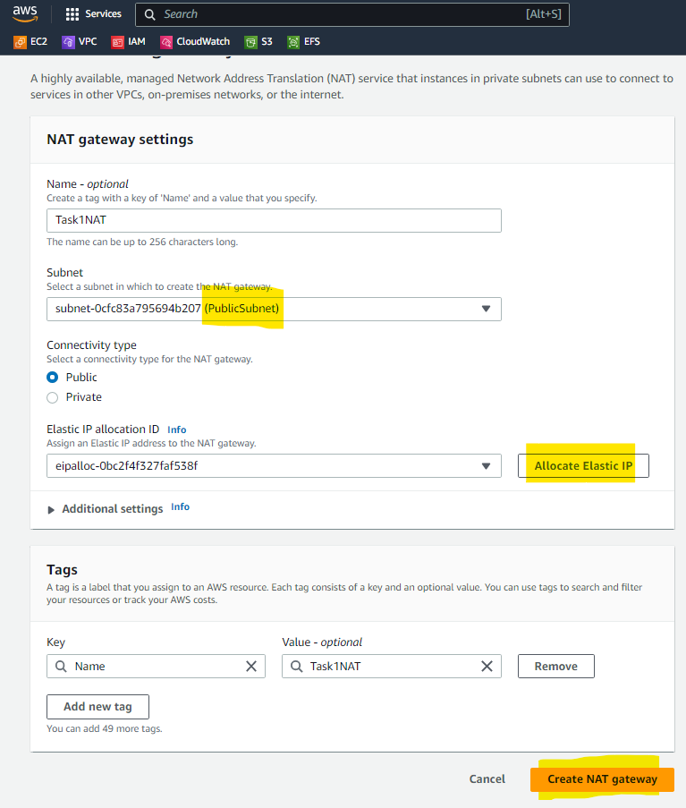

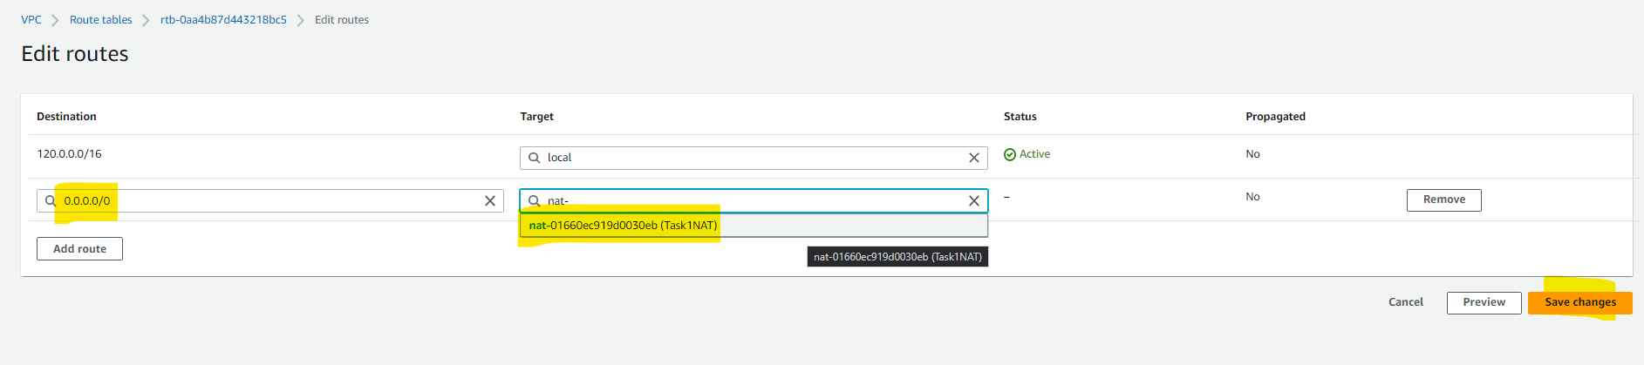

1. Please find below the Resource Map. The ask of Task 1 has been completed successfully.

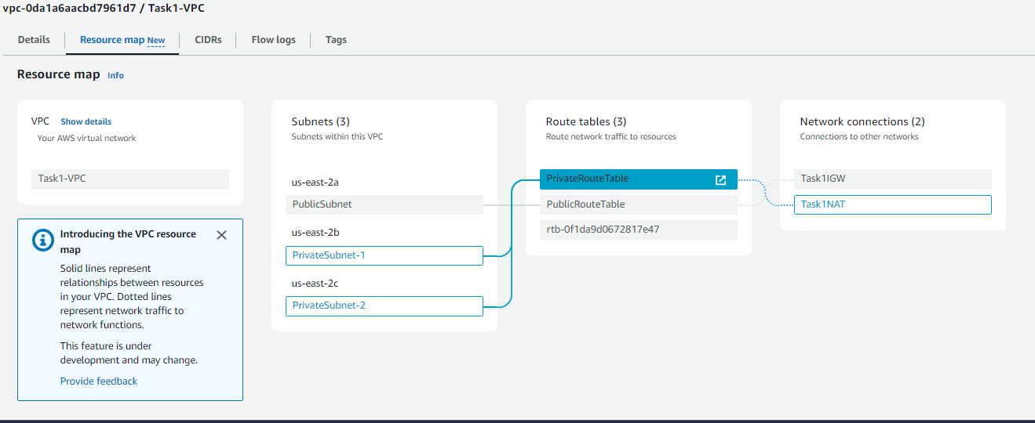

**Module 4 – Task 2**

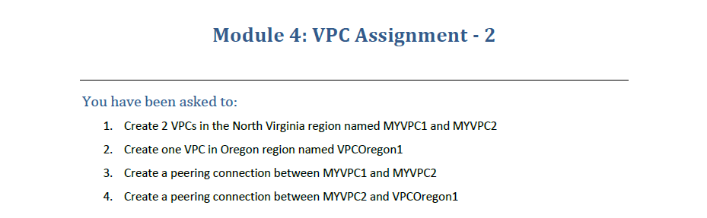

**VPC Assignment**

1. Select North Virginia Region and Create VPC’s

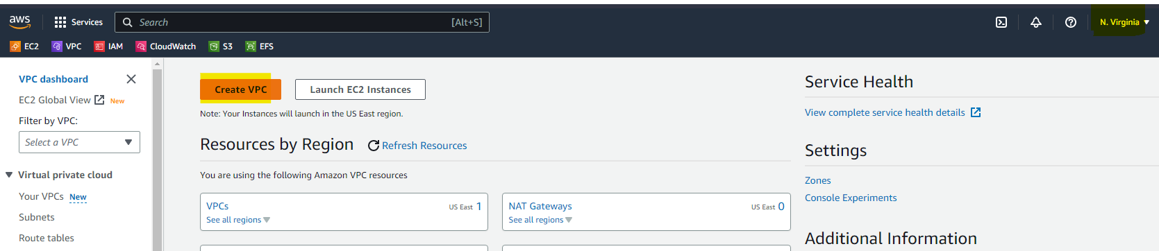

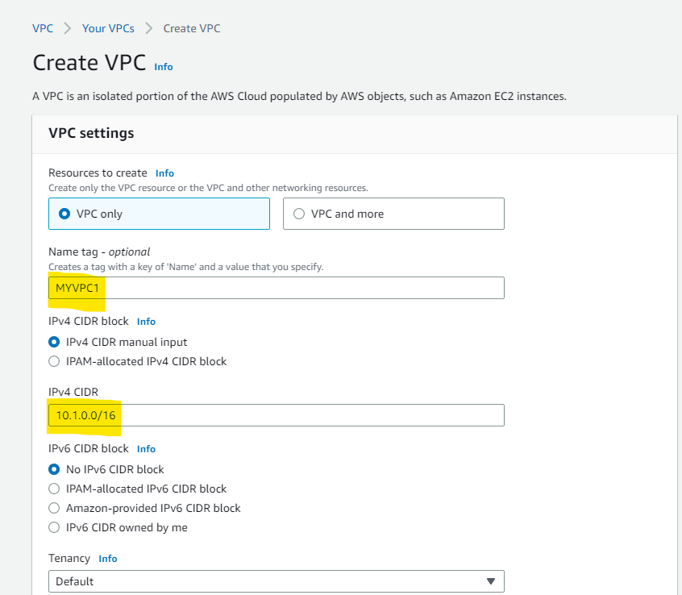

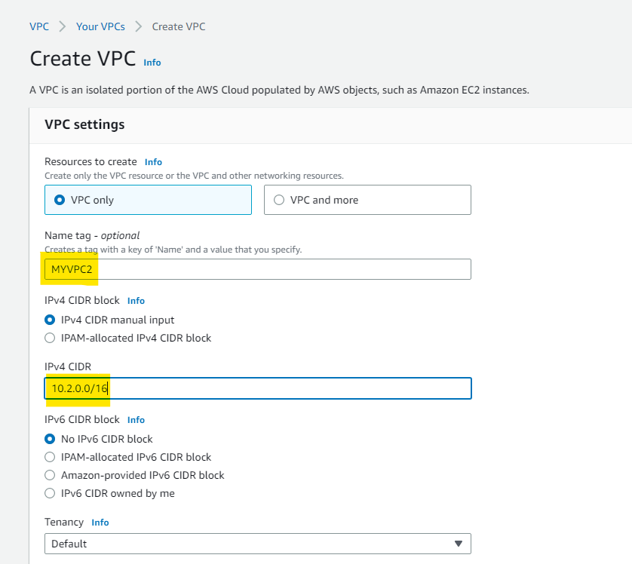

1. Go to Oregon Region and Create one VPC.

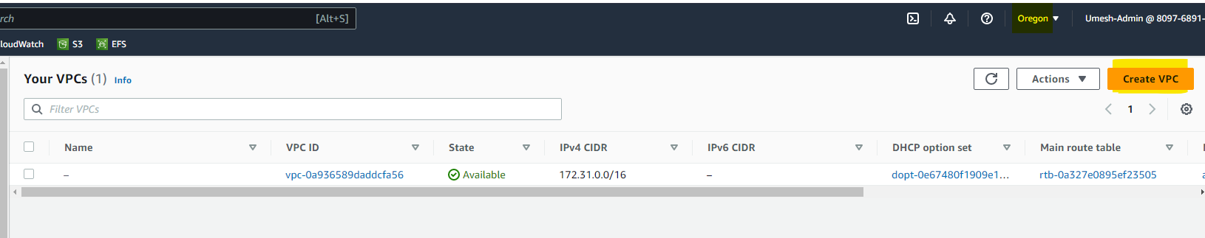

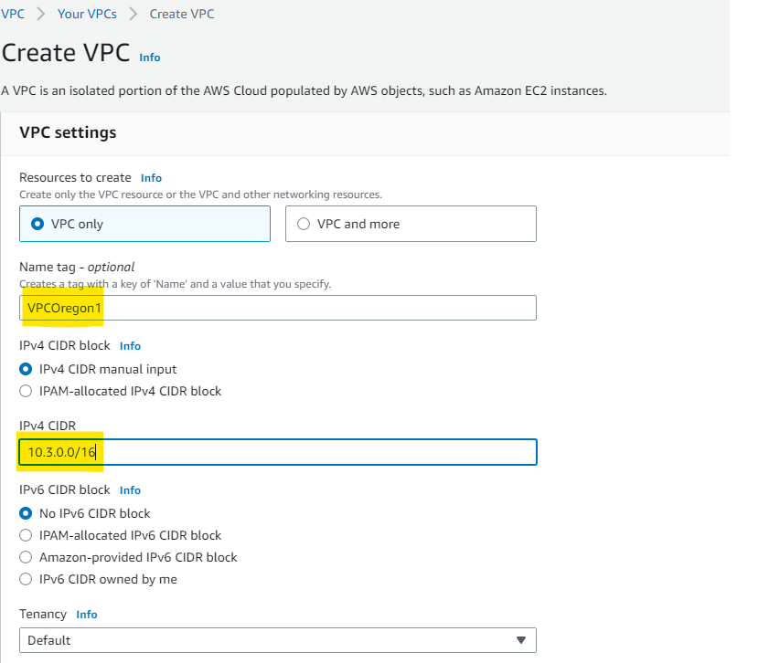

1. To Peer the VPC between MYVPC1 and MYVPC2, go to VPC > VPC Peering and choose Create Peering Connection.

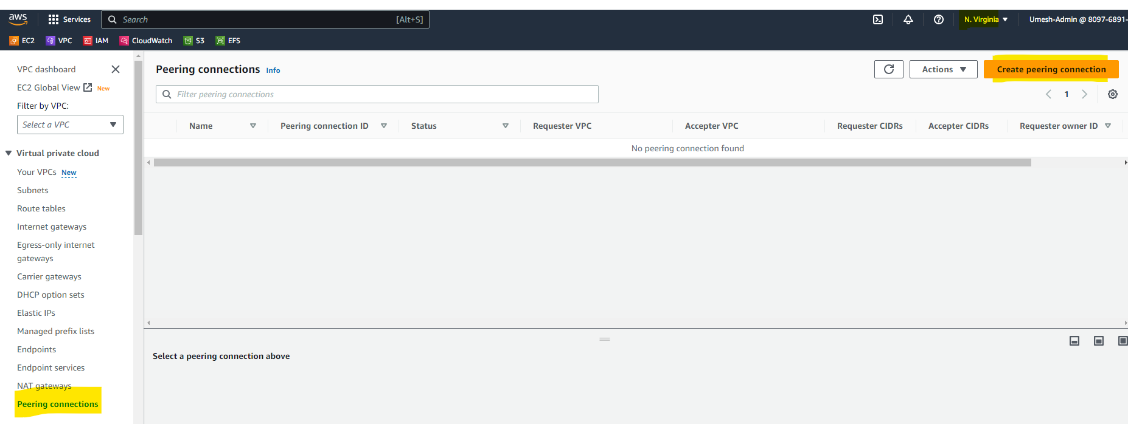

1. Select Same Region since MYVPC1 and MYVPC2 exist in the Same Region, Select My Account since it also resides within the Same Account.

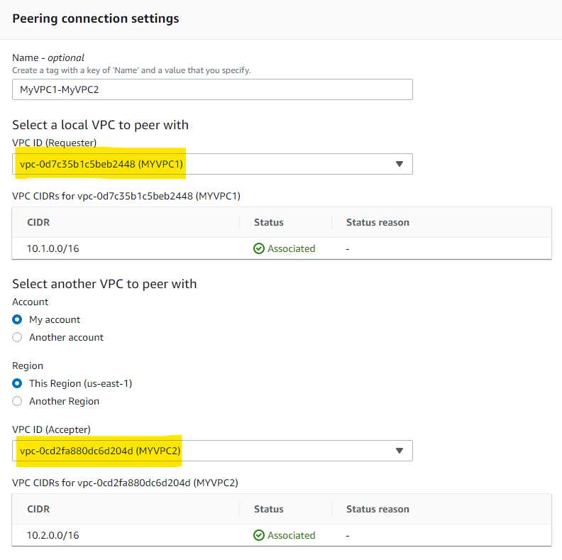

1. Accept the Request.

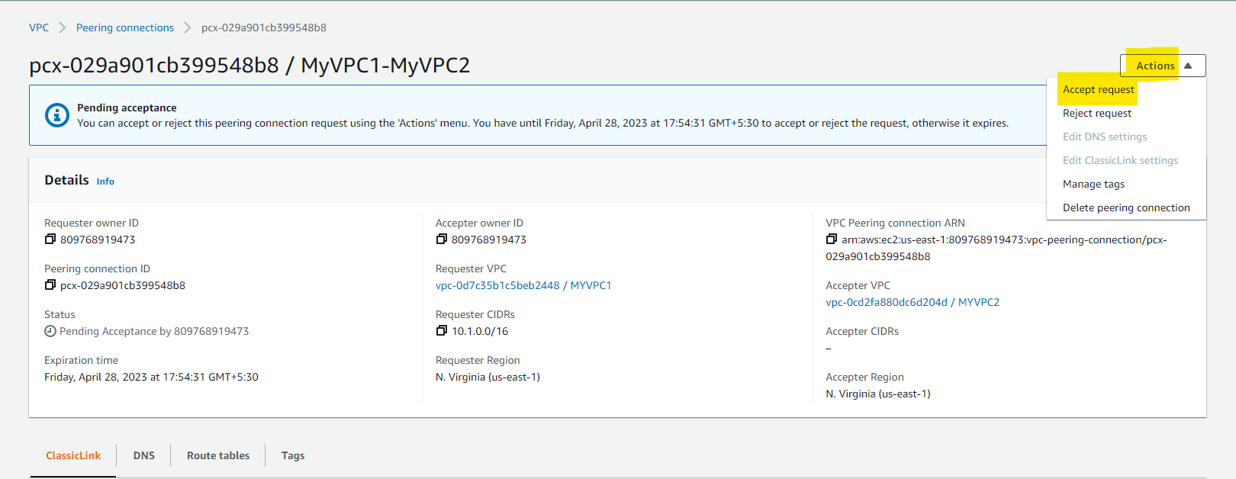

1. MYVPC1 and MYVPC2 have been Peered.

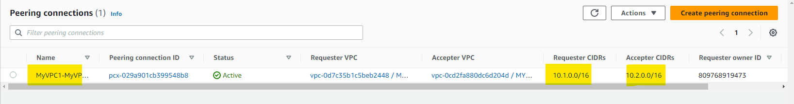

1. To Peer MYVPC2 and VPCOregon1, follow the same steps. Select Another Region since Oregon is a different Region. Also, copy the VPC ID of VPCOregon1.

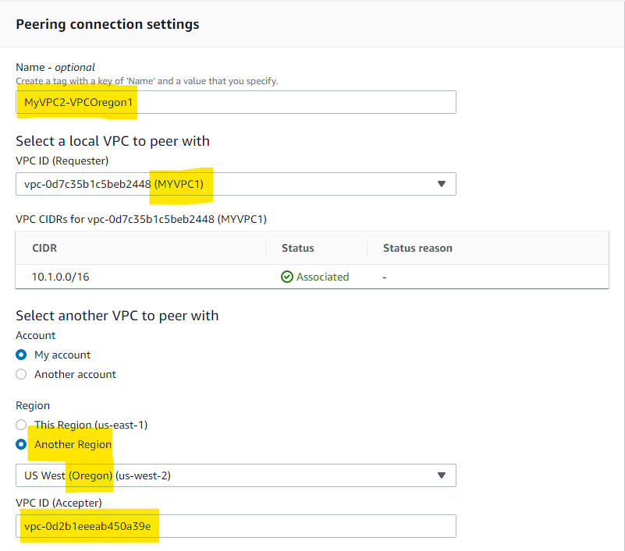

1. Go to Oregon Region, under VPC > Peering Connection. Click on Action > Accept Request to Peer MYVPC2 and VPCOregon1

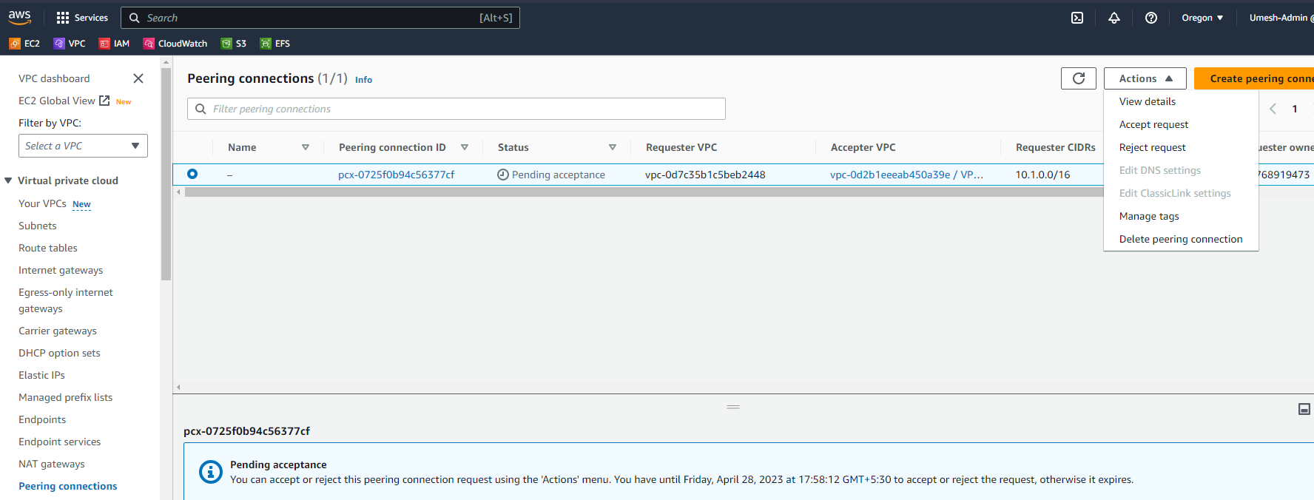

1. All the VPCs have been Peered Successfully.

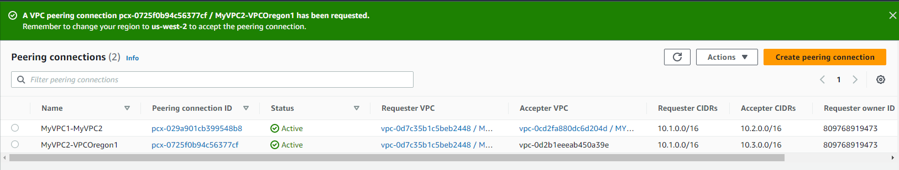

**Module 4 – Task 3**

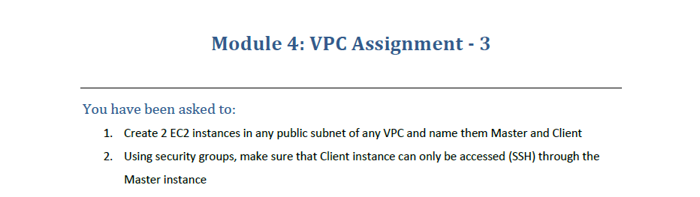

**VPC Assignment**

1. Go to EC2, Create 2 EC2 Instance and Modify the Network Settings and Choose a Public Subnet. Do not assign Public IP to Client Server.

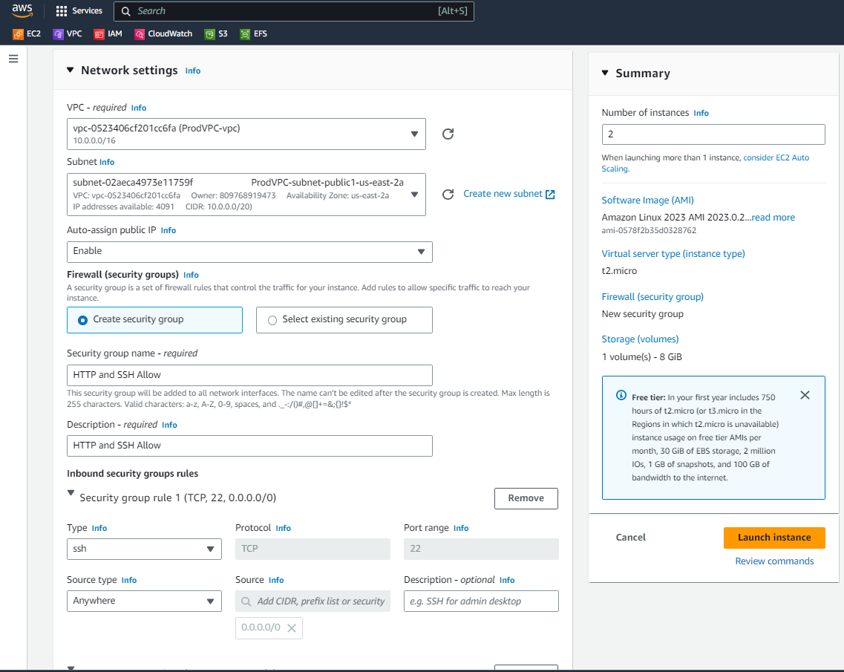

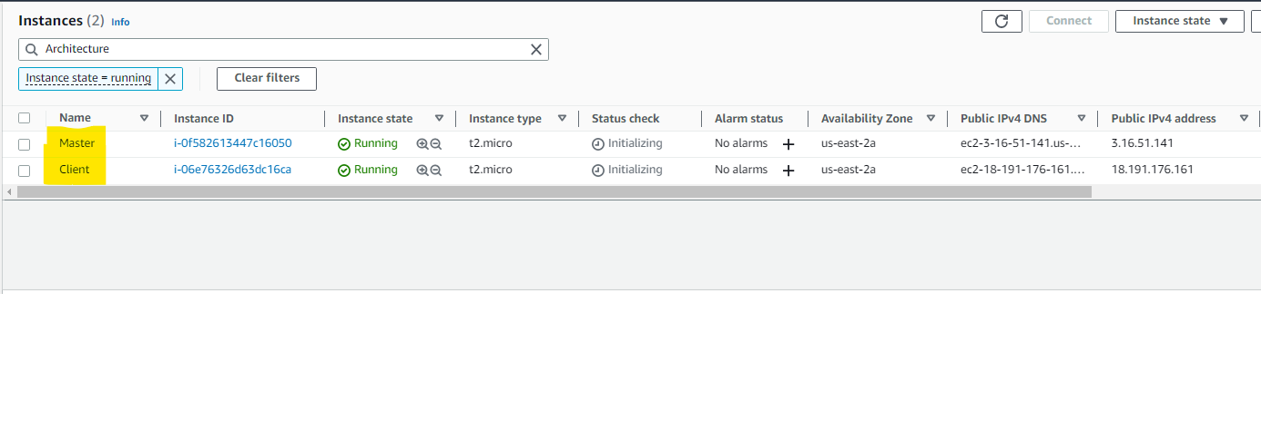

1. Make sure Client SG doesn’t have Inbound All Traffic. Allow only SSH from Master’s SG.

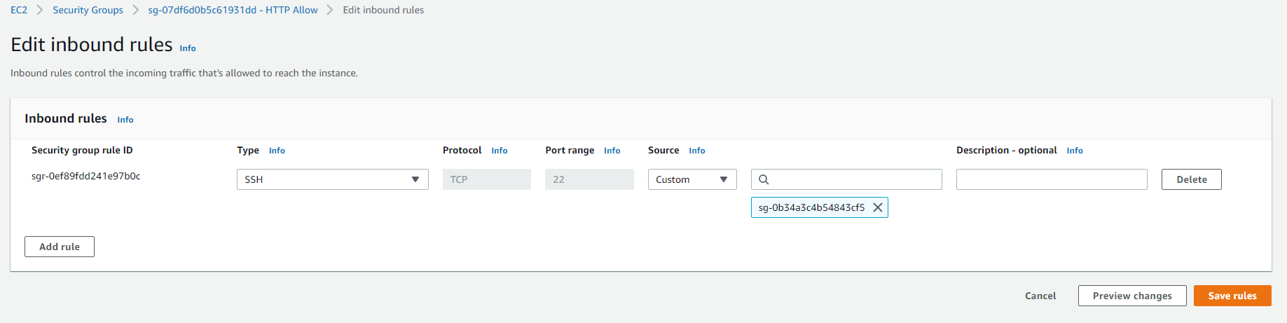

1. Connect to Master Instance, create a .pem file with the Key Pair Info. Connect to Client Instance by using Private IP. Eg: ssh -i "private.pem" [ec2-user@172.31.3.249](mailto:ec2-user@172.31.3.249)

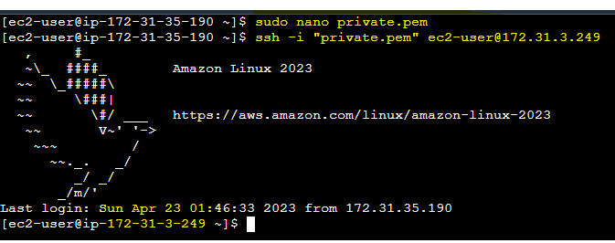

1. As you can see, Client Server is only Accessed by Master Instance and Master’s SG in any other Instance.

**Module 4 – Task 4**



**VPC Assignment**

1. Go to VPC > Endpoints

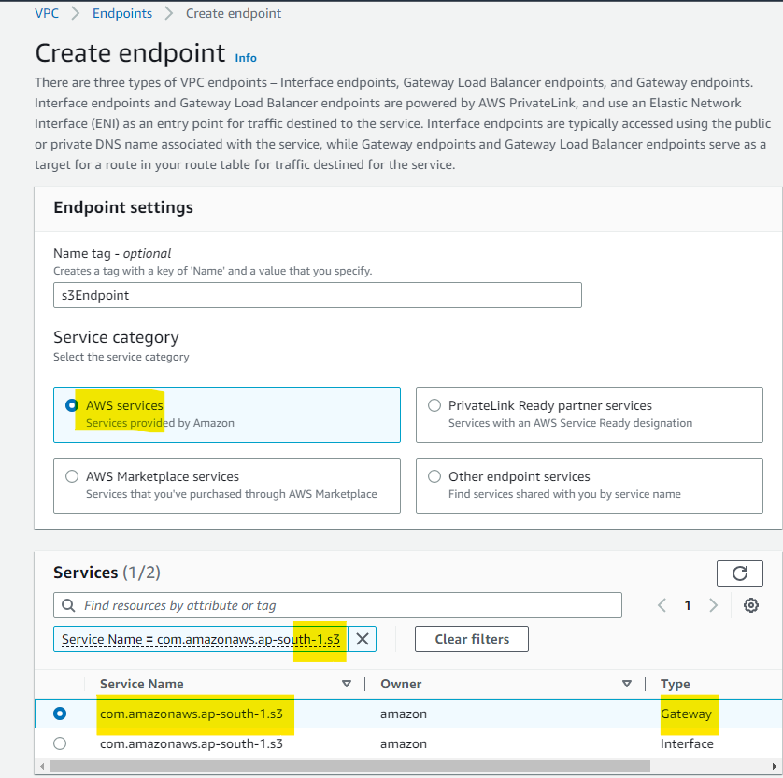

1. Select the VPC and Create the Endpoint.
2. You can use this Endpoint to connect securely within the VPC. It won’t be publicly accessible.

**Module 4**

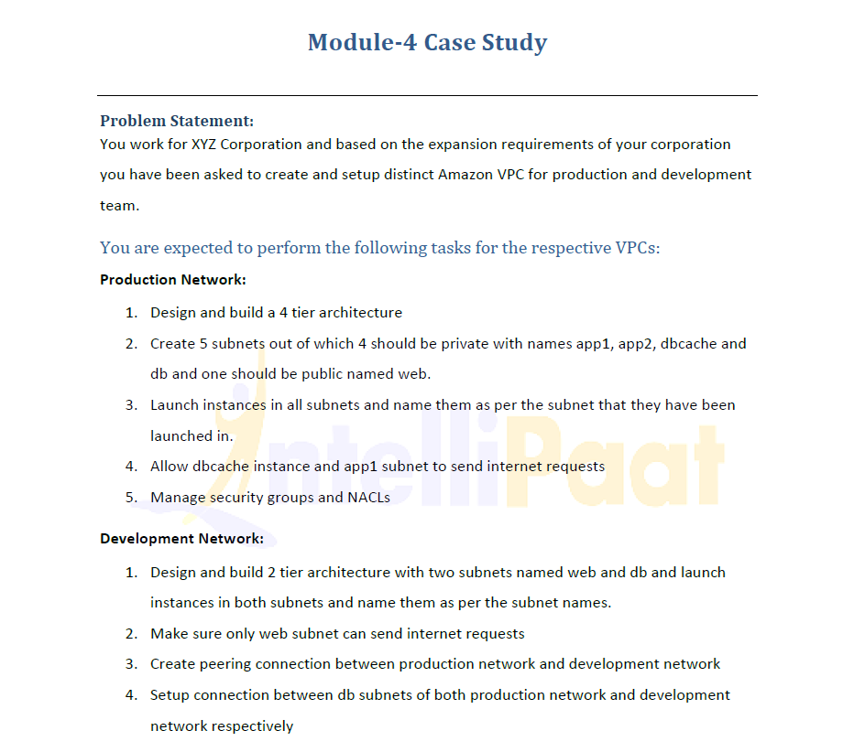

**VPC Assignment**

1. Create 2 VPC (Prod and Dev)

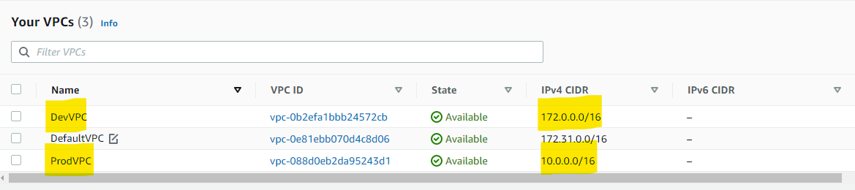

1. Create 4 Private Subnets (app1, app2, dbcache and db) and 1 Public Subnet (web)

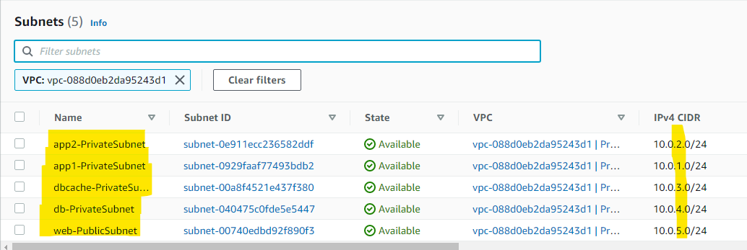

1. Create the Route Table for the Private and Public Subnets and associate the respective Subnet.

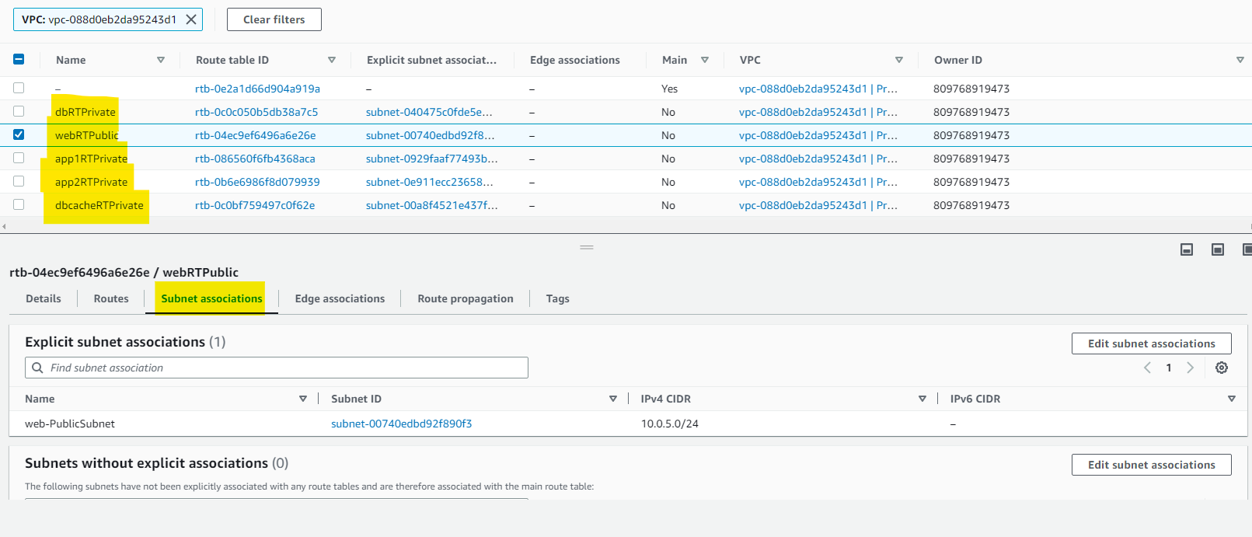

1. Attach Internet Gateway to the VPC and Edit the Route in Public Subnet to access the Internet. Also, deploy NAT Gateway in Public Subnet so that dbcache and app1 (Private Subnets) can send Internet Request.

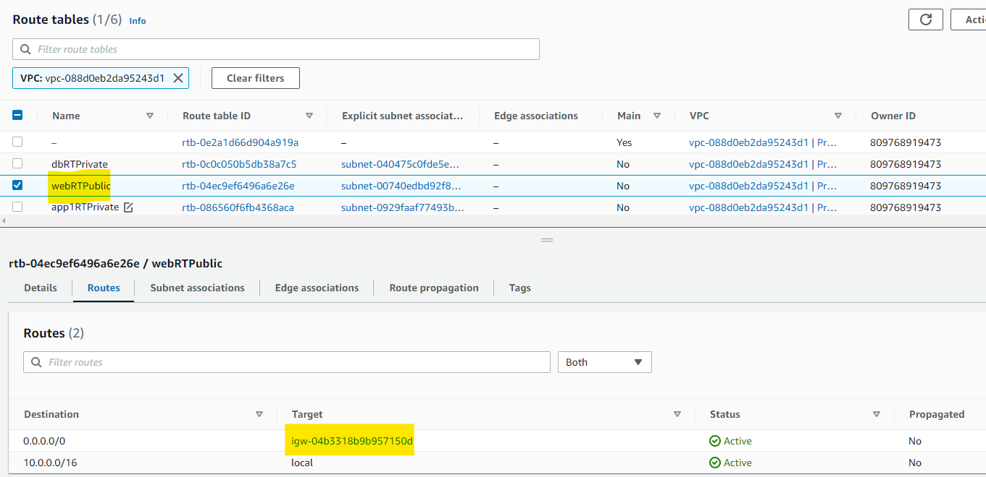

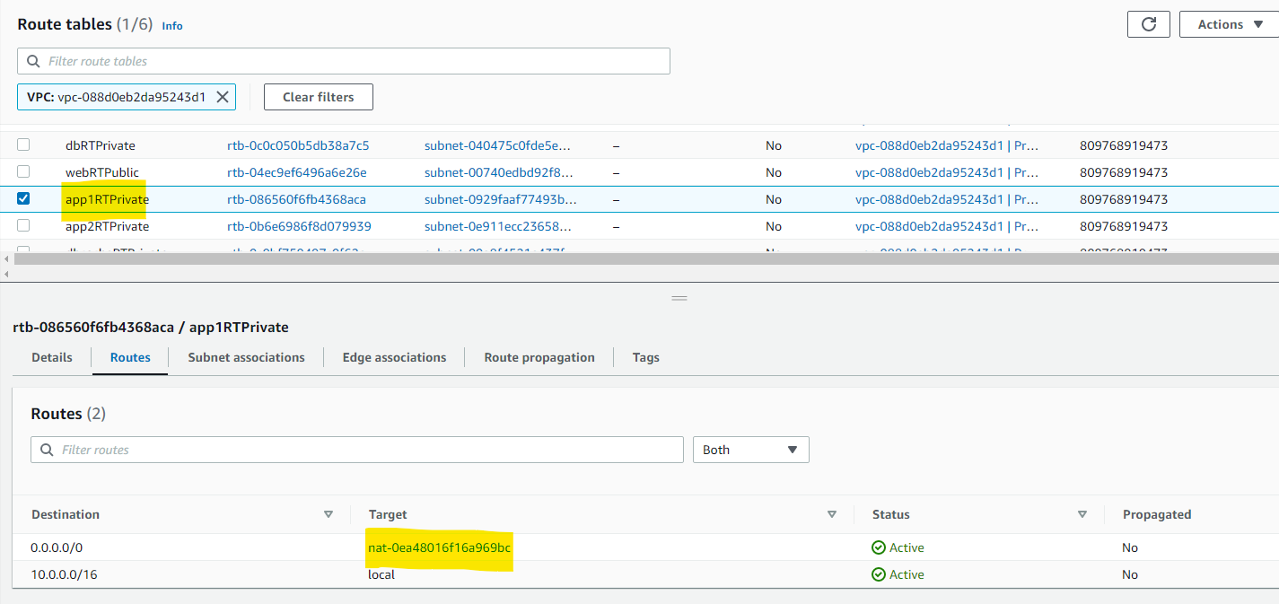

1. Deploy the Instances on their Respective Subnets and Test Internet Connectivity Respectively.

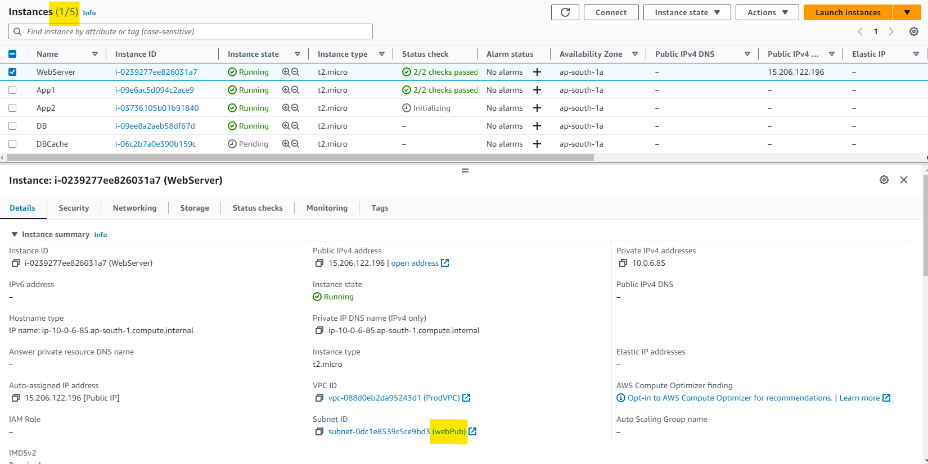

* 1. For Web Instance : Assign Public IP and Allow HTTP and SSH SG.

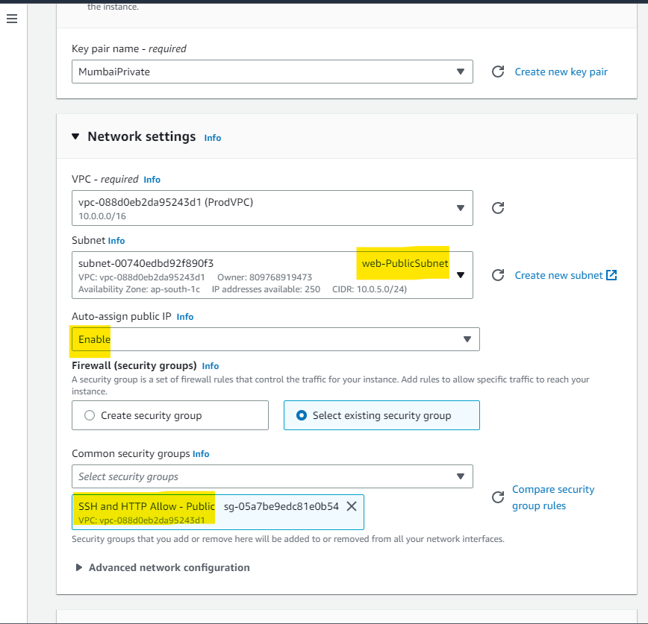

* 1. For the rest of the Instances, Disable Auto Assign allow only SSH Traffic (So that WebServer can Connect to Other Instance).

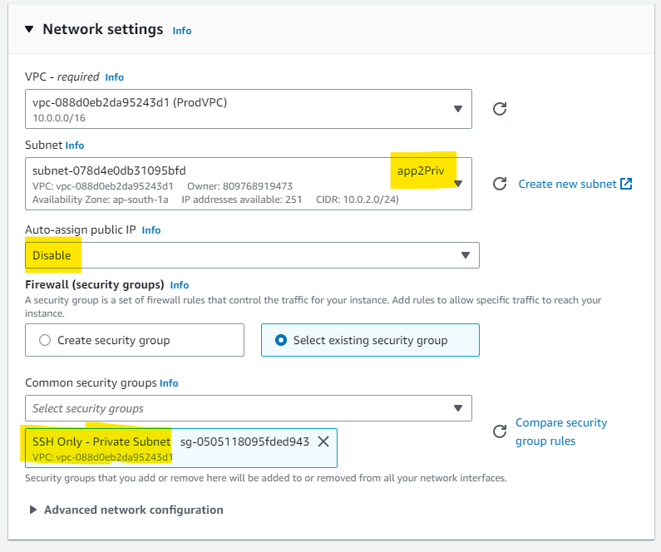

1. Find below output of Internet Connectivity on DB and DBCache via WebServer.
   1. DB (No Internet Connectivity)

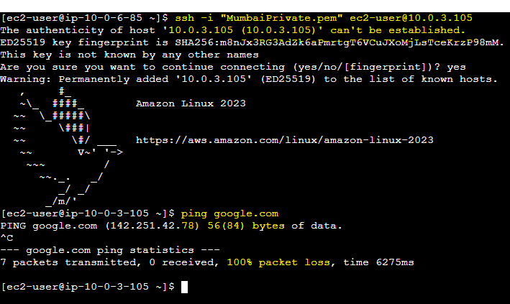

* 1. DBCache (Able to send Internet Request)

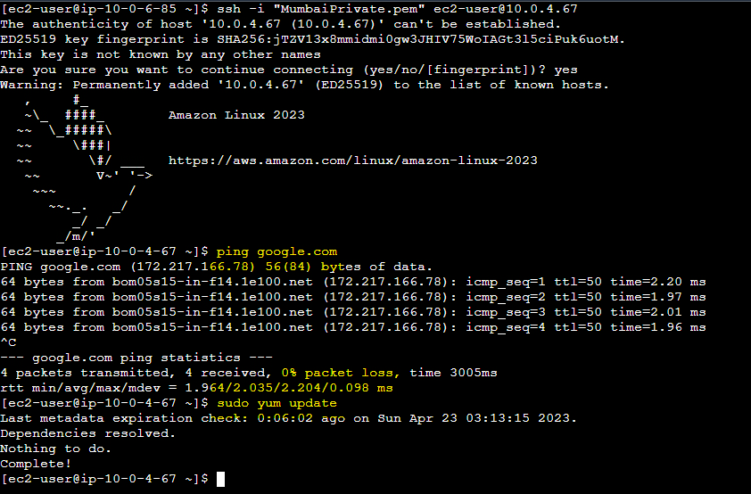

1. Production Network has been Completely Setup.
2. For Development Network, Create 2 Subnets Web and DB.

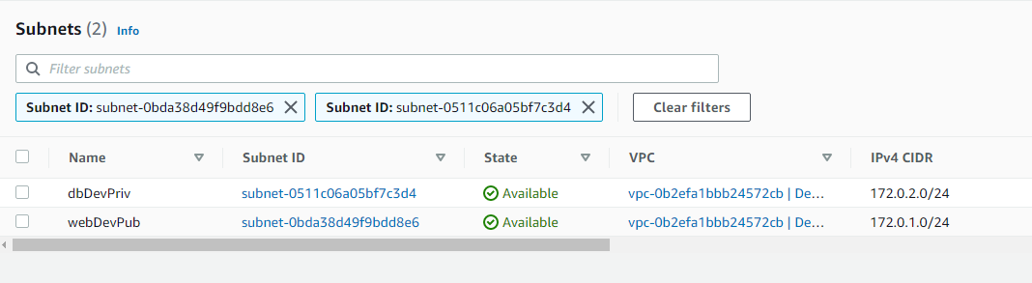

1. Create 2 Route Table for Web and DB. Associate respective Subnets and Attach IGW to Web Route.

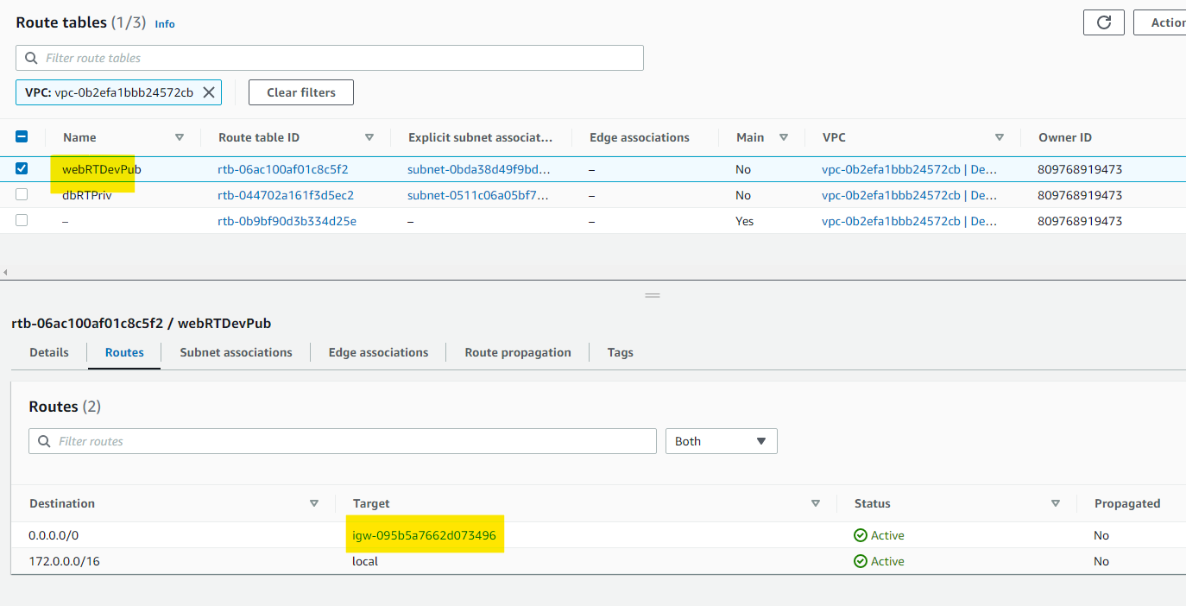

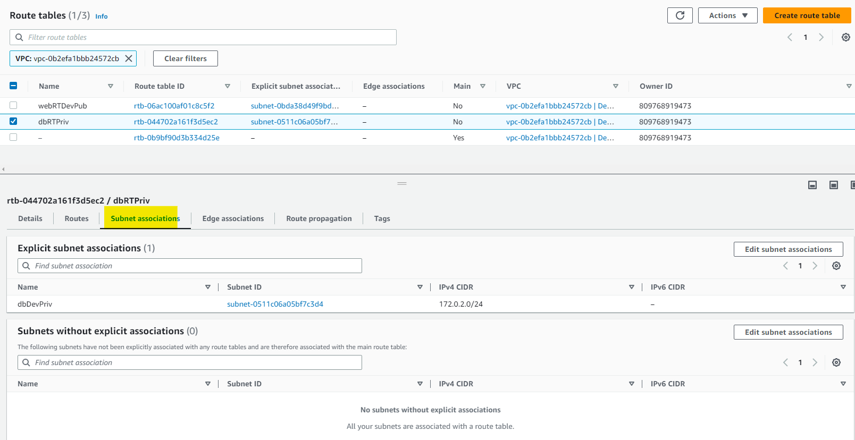

1. Deploy 2 Instance (Web and DB) in Dev Environment.

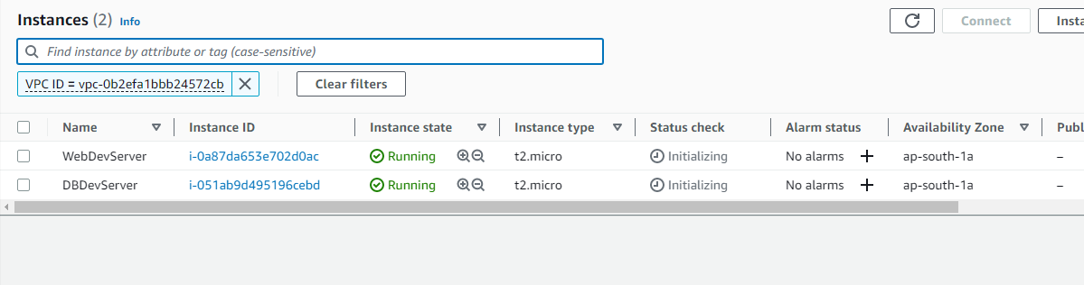

1. Only Web Instance is able to Send Internet Request.

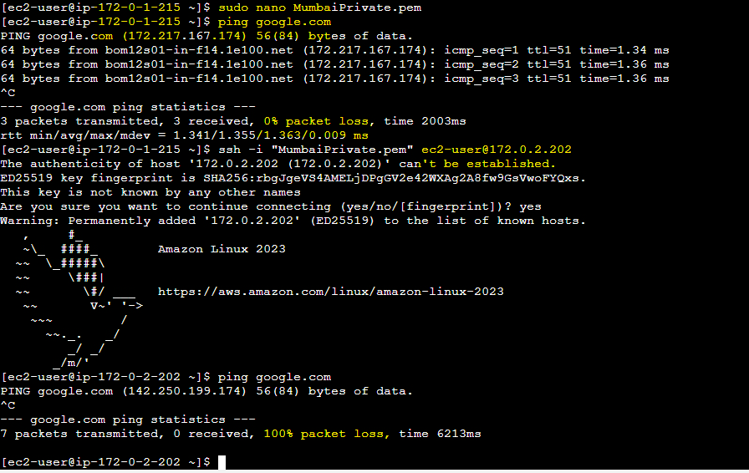

1. Peer both the VPC.

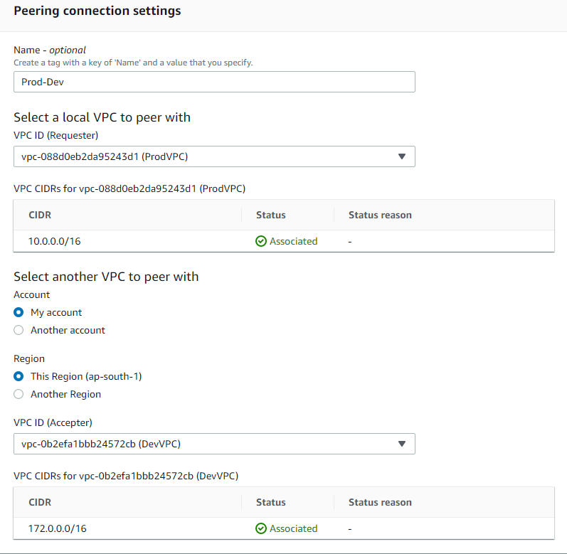

1. Configure the Route Table and add the Peering Connection in all the DB Route Table.

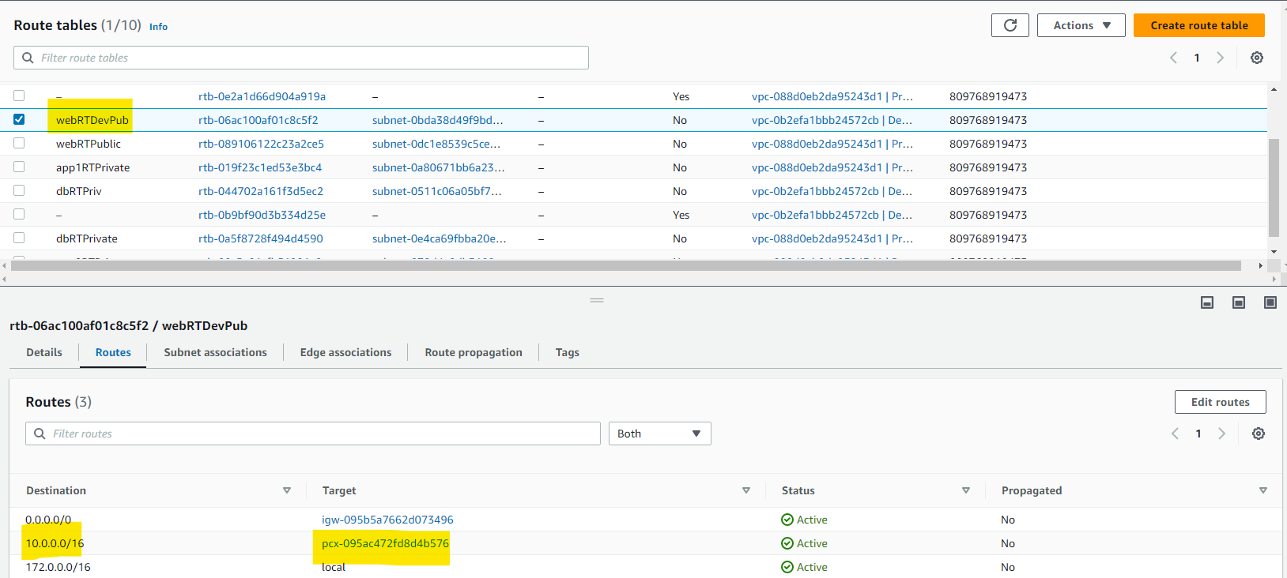

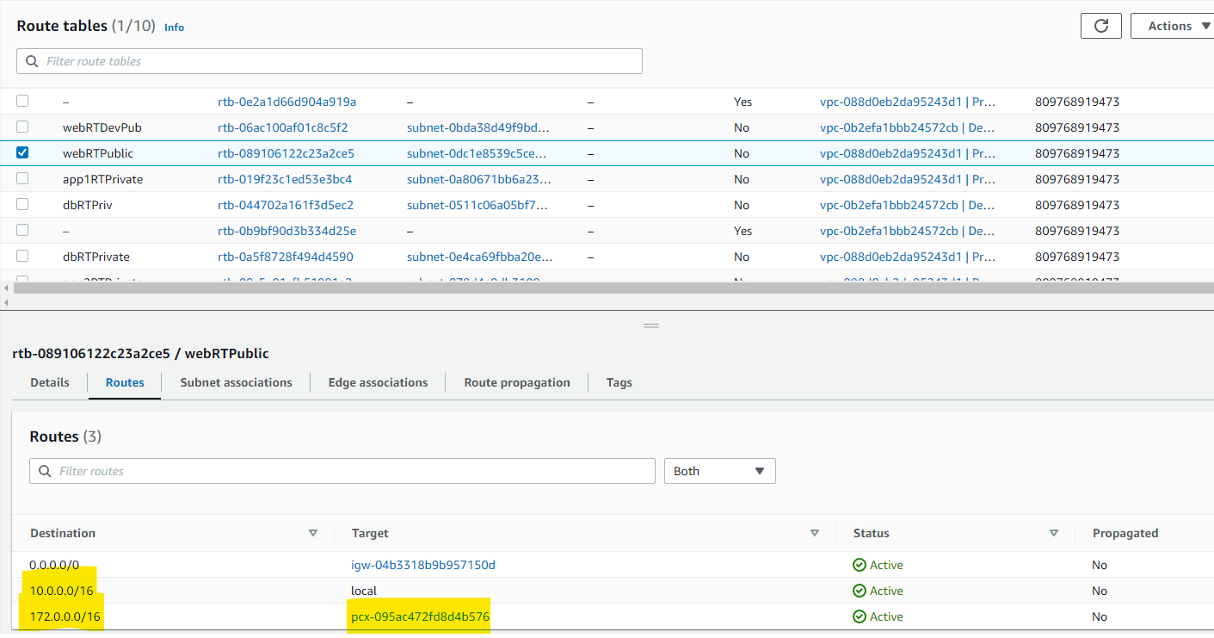

1. Verifying DB (Prod) to DB (Dev) Connectivity.

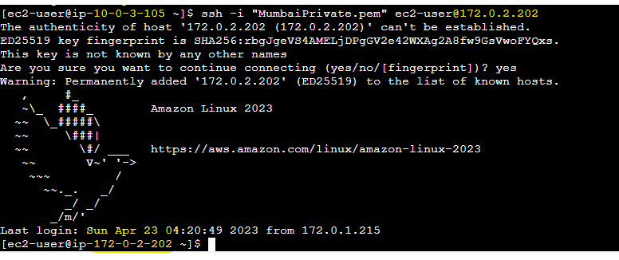

1. Verifying DB (Dev) to DBCache (Prod) Connectivity.

